

Coronado15 Association
Bylaws - Revised August 2024
(most recent updates highlighted in red)

Contents
ARTICLE I - NAME 3
ARTICLE II - OBJECTIVE 3
ARTICLE III - POLICY 3
ARTICLE IV - JURISDICTION 3
ARTICLE V - FLEETS 3
ARTICLE VI - DISTRICTS 4
ARTICLE VII - MEMBERSHIP 5
ARTICLE VIII - BOARD OF DIRECTORS 5
ARTICLE IX - FLAG OFFICERS 6
ARTICLE X - DIRECTORS AND APPOINTED OFFICERS 6
ARTICLE XI - ANNUAL MEETING 7
ARTICLE XII – DUES 8
ARTICLE XIII - SANCTIONED EVENTS 8
ARTICLE XIV - AMENDMENTS 9
ARTICLE XV - PARLIAMENTARY AUTHORITY 9
ARTICLE XVI - RACING RULES 9
ARTICLE XVII MEASUREMENT CERTIFICATE AND DECALS 11
ARTICLE XVlll SPECIFICATIONS 12
ARTICLE XlX MODIFICATIONS 17
MEASUREMENT RULINGS 18
BOARD POLICIES 18
CORONADO 15 MEASUREMENT GUIDE 20
CENTERBOARD 23
RUDDER 24
MEASURING RADIUS FOR RUDDER AND CENTERBOARD 25
MAIN SAIL 26
JIB 27
Revisions: 29

ARTICLE I - NAME
The name of this organization shall be the CORONADO 15 Association, hereinafter referred to as the Association.

ARTICLE II - OBJECTIVE
The objective of the Association is to promote CORONADO 15 Class racing under uniform rules and regulations, and to maintain the one-design features of the CORONADO 15 Class Sloop.

ARTICLE III - POLICY
SECTION 1 To cooperate with other yachting organizations, and in return, to insist on strict observance and compliance with the rules of the Association.
SECTION 2 To keep the cost of acquisition and upkeep of CORONADO 15 Class Sloops within modest limits without sacrificing high standards of performance and seaworthiness.
SECTION 3 To promote and maintain a one-design class of CORONADO 15 Sloops in order that racing shall determine the skill of skipper and crew under uniform rules and specifications.
SECTION 4 The Association shall be operated on a fiscal year basis from January 1 to December 31 of each year.

ARTICLE IV - JURISDICTION
SECTION 1 The Association has jurisdiction over all CORONADO 15 Class activities. Its Bylaws govern all CORONADO 15 Class races, regardless of sponsor and are binding upon all members and fleets,
SECTION 2 In order for a CORONADO 15 Stoop to be raced in any race, whether it be a class race or a handicap race, the sloop and the sailor(s) shall meet all requirements of this Association.
SECTION 3 Permission must be obtained for the Association prior to eliminating or deviating from any requirement of the Bylaws in racing a CORONADO 15 Class Sloop.
SECTION 4 All events involving racing within the territorial waters of a Fleet shall be sanctioned by the Fleet through its elected officers.
SECTION 5 All disputes between Fleets, or a Fleet and other yachting organizations, regarding the Interpretations of the Bylaws shall be resolved by the Board of Directors of the Association, and its decision shall be final.
SECTION 6 The Association shall not be liable for any debts contracted by the officers, Fleet officers, or members, other than the expenditures authorized by the budget or upon written order of the Commodore and Treasurer.
SECTION7 The association reserves the right to declare ineligible any sloop which does not conform to the SPIRIT as well as the letter of these Bylaws, and the specifications and drawings of the CORONADO15.

ARTICLE V - FLEETS
SECTION 1 A Fleet is a territorial unit open to all eligible persons who sail within its area. It elects its own officers, which should include a Fleet Captain. Fleet Secretary and Fleet Measurer. The Fleet is self-governing in all local matters not conflicting with the CORONADO 15 Association Bylaws, and has the authority to accept or reject application for Fleet membership.
SECTION 2 At the option of the Fleet, it may be divided Into divisions In an attempt to equalize performance based upon skill or equipment used.
SECTION 3 A new Fleet may be granted a charter upon application to the Board by owners of three or more boats, who must be members in good standing of the Association.
SECTION 4 In order to renew its rights and privileges, each Fleet shall, upon request, file the following reports not later than November 15 of each year.
- An Annual Report of Membership must be filed with the Association Secretary. This report shall consist of a complete roster of membership and current Fleet Officers.
- An Annual Report of Measurement must be filed with the Association Measurement Chairman. This report shall consist of a complete measurement status of each Individual Fleet Member's boat.
SECTION 5 Fleet Charters may be granted, suspended or altered by the Board, but revoked only at an annual meeting. Reasons for suspension are:
- Failure to maintain in good standing, the minimum membership quota of CORONADO 15 Class Sloops.
- Failure to file the Annual Reports required by Article V, SECTION 4 of these Bylaws.
- Failure to comply with these Bylaws knowingly or otherwise.
SECTION 6 Suspended Fleets shall be posted by publication. A suspended fleet cannot be reinstated until requirements of the Association have been fulfilled. After fulfilling Association requirements, a Fleet must petition the Board for reinstatement. Individual members of a suspended fleet will be considered suspended unless meeting the following:
- Have paid Association dues for the current fiscal year.
- Have contacted the Association Measurement Chairman and made appropriate arrangements for verification of measurement requirements.
- Have met all other membership requirements contained In Article VII - Membership of these Bylaws.
SECTION 7 Each Fleet shall hold an annual meeting for the purpose of selecting Fleet officers. The results of that meeting shall be filed with the Association Secretary as soon as possible.
SECTION 8 The amount and time of payment of Fleet dues shall be fixed by each Fleet.

ARTICLE VI - DISTRICTS
SECTION 1 Groups of Fleets may be organized Into Districts. The Association Commodore with approval of the Board will establish District boundaries.
SECTION 2 Each District shall have a District Secretary whose duties are outlined In Article X, SECTION 1b - Appointed Officers.

ARTICLE VII - MEMBERSHIP
SECTION 1 The membership of the Association and of its Fleets shall consist of two grades: Regular Membership, and Junior Membership. A person qualifying under a particular membership will hereinafter be referred to as a member. Membership grades are defined as follows:
- Regular Membership - The registered owner(s) or Immediate family members of a CORONADO 15 Class Sloop or a non-Coronado 15 Class Sloop owner who Is Interested In the promotion of the Association are eligible for Regular Membership subject to the following restrictions:
  - Membership privileges are for one fiscal year beginning January 1.
  - Pertaining to Association matters, only one vote per registered boat is permitted.
  - Any Association Member Is eligible to race in the crew's position or in the skipper's position. Each racing boat must have at least one Coronado 15 Association Member In good standing as part of the team.
  - Any member meeting the requirements of Regular Membership Is subject to the rules and Bylaws of the Association.
  - Any member meeting the requirements of regular membership and considered a member in good standing, unless the member is not a Coronado 15 Class Sloop owner or part owner. Is privileged to hold office In accordance with the Bylaws.
- Junior Member - An Individual who meets the qualifications for a Regular Member, but who has not yet reached his/her 18th birthday by January 1. The beginning of the fiscal year. A Junior Member who would otherwise qualify as a Regular Member shall have all the rights and privileges of Regular Member.
SECTION 2 Members who are delinquent In Association dues, fines, or fees shall be ineligible and disqualified from racing until such monies are paid.
SECI'ION 3 Any member may be expelled from the Association, by three quarters vote at an Annual Meeting, or by a two-thirds vote of the Board of Directors. Article VIII. SECTION 4.
SECTION 4 New applicants for membership shall not be considered eligible to race In the COIRONADO 15 Class until all measurements, registration, and paid up dues are recorded by the Fleet to which he/she belongs, if one exists, and the Association.
SECI'ION 5 When a member ceases to be a CORONADO 15 Class Sloop owner, his/her membership shall be retained until the end of the fiscal year.
SECTION 6 A member may belong to more than one fleet at one time; however, he/she may be eligible for a Fleet Championship In only one Fleet each year.

ARTICLE VIII - BOARD OF DIRECTORS
SECTION I The Board of Directors, hereinafter referred to as the Boar shall consist of live Flag Officers (Commodore, Vice Commodore, Hear Commodore, Secretary, Treasurer) Measurement Chairman, Junior Staff Commodore, Honorary Director, District Secretaries, Publication(s) Editor(s) and Factory Liaison.
SECTION 2 For purposes of doing business, a quorum shall consist of a majority of Flag Officers.
SECTION 3 The Board shall conduct all business, determine policy of the Association, and shall serve as the last court of appeal In disputes Involving these Bylaws.
SECTION 4 The Board has the authority to enforce its decisions by suspension of entire Fleets or individual members. The Board may sanction or ban races, grant or suspend Fleet Charters, and suspend members guilty of gross violation of rules or unsportsmanlike conduct. Its rulings shall be binding and final. A two-thirds majority vote shall decide all Issues.

ARTICLE IX - FLAG OFFICERS
SECTION I Commodore - The Commodore Is the chief executive and shall preside at meetings. serve as Chairman of the Board, rule on procedure and Jurisdiction, summarize decisions, appoint Directors and special committees, and authorize payment of all bills with approval of the Board. In addition, the Class North American Championship Regatta, the Class Junior North American Championship Regatta, and all class development programs will be delegated to the flag officers as appropriate.
SECTION 2 Vice Commodore - The Vice-Commodore shall officiate in the absence of the Commodore.
SECTION 3 Rear Commodore - The Rear Commodore shall officiate in the absence of the Commodore and Vice Commodore.
SECTION 4 Secretary - The Secretary shall handle all correspondence, retain the minutes of meetings. and maintain an accurate and current record of members. Fleets and Fleet Officers. He/she shall notify the membership of special events, decisions affecting policy, banned races, suspended members and/or Fleets, and ineligible CORONADO 15 Class Sloops.
SECTION 5 Treasurer - The Treasurer shall be responsible for protection and custody of cash receipts, financial disbursements as approved by the Board, maintaining financial records, and financial reporting at meetings.
SECTION 6 Election of Flag Officers -
- All Flag Officers shall be elected at the annual meeting of the Association for a term starting September I of that year.
- Each Flag Officer shall be nominated, seconded, and voted upon separately by the Fleet delegates in the order named.
- Candidates shall be presented by the Junior Stan' Commodore who will be chairman of a Nominating Committee consisting of himself and at least two other former Commodores.

ARTICLE X - DIRECTORS AND APPOINTED OFFICERS
SECTION I Directors
- Measurement Chairman - The Measurement Chairman shall be In charge of all certified measurers within the Association. At the Class North American Championship Regatta he/she shall be responsible for boat certification. He/she shall grant or reject all measurement certificates, Issue duplicates, and answer all questions from Fleet Measurers regarding measurement rules. He/she shall Interpret the rules and regulations on matters not specifically covered In the official plans and specifications. Such rulings shall be subject to approval of the Board. The Measurement Chairman shall not approve changes In construction specifications, sail plan, or rigging. Rulings of the Measurement Chairman approved by the Board, shall be Included In an annual report of the Measurement Chairman.
- District Secretaries - Within the guidelines of these Bylaws. a District Secretary shall have general supervision of all Association activities In his/her District. He/she shall coordinate policy and decisions of the Board with each Fleet In the District. He/she shall coordinate the Social and racing activities of all the Fleets In his/her District and shall make up and disseminate a calendar of events. He/she shall encourage all non-member boat owners to affiliate with a Fleet and the Association. He/she shall continue correspondence with the Association Secretary for the purposes of maintaining Association records.
- Junior Staff Commodore - The Junior Staff Commodore shall be the Immediate past Association Commodore. He/she shall provide a smooth transition of Association affairs and policies to the succeeding Board of Directors. He/she shall be the Chairman of the Nominating Committee to prepare a slate of officers for the following year.
- Honorary Director - In recognition of Frank W. Butler's outstanding services to the CORONADO 15 Class. he shall hold the office of Honorary Director permanently.
- Publicity Chairman - The Publicity Chairman shall collect Fleet. District, and Association articles of regattas and special events and shall report such news to external publishers.
- Publication(s) Editor(s) - The Publication(s) Editor(s) shall collect and edit Information, reports, and articles for the Association newsletter, the official publication of the Association. He/she shall select a publisher and oversee the printing and distribution of the editions. He/she shall also have charge of the editing and publication of the annual yearbook and any other class publications.
- Factory Liaison - A person shall be appointed as a Factory Liaison to maintain a contact between the Association and the builder so as to pass Information to the Board about developments In boat production, and to pass on to the builder suggestions for further Improvement of the boat. One person may be appointed for each factory building the Coronado 15 Sloop.
- The Directors shall be appointed by the Commodore by December 31.
SECTION 2 Appointed Officers
- Rules Chairman - The Rules Chairman shall head the Racing Rules Committee and evaluate and make recommendations to the Board regarding changes In the Bylaws of the Association
- Special committees may be appointed by the Commodore at any time.

ARTICLE XI - ANNUAL MEETING
SECTION 1 The annual Meeting of the Association shall be held during the period of, and In the vicinity of, the Class North American Championship Regatta. Special meetings by order of the Board, or upon demand In writing by twenty-five percent of the Fleets, must be held. Time and place of all meetings shall be fixed by the Board.
- Notice of a meeting shall be sent to the last recorded Secretary of each Fleet In time to permit action by delegate or proxy. If It ls a Special Meeting, the purpose thereof must be plainly stated In such form as to permit voting by mall. No business other than that stated may be transacted at a Special Meeting.
- The membership of each Fleet shall select and instruct a delegate. If unable to send a delegate, the Fleet shall sign and deliver to the Secretary of the Association, a duly authorized proxy to present the Fleet's views and cast its votes at the meeting.
- Each Fleet shall be entitled to cast one vote for each CORONAOO 15 Class Sloop enrolled in that Fleet, which has been properly recorded with the Association by an active member in good standing. No Fleet ls entitled to more than thirty, three and one-third percent of the total number of votes cast. No more than one vote shall be allowed for any one member, no matter how many CORONAOO 15 Class Sloops he/she may own. Membership books close 30 days before any meeting, or as ordered by the Board.
- Members may be heard, but only delegates shall vote on motions. All Fleet delegates must vote or be recorded as abstaining on each motion unless excused by the Chairman of the meeting. A majority of votes cast shall decide all questions not otherwise stipulated, and the Chair shall cast the one deciding vote In case of a tie and may also fix a time limit on speakers and debate of motions.
SECTION 2 The order of business at the Annual Meeting shall be:
- Call to Order
- Roll Call of Fleets
- Minutes of Last Meeting
- Reports of Executive Officers
- Reports of Charters Granted and Revoked
- Unfinished Business
- New Business
- Election of Officers
- Adjournment

ARTICLE XII – DUES
SECTION 1 Association dues must be paid before any member can be considered In good standing. Paying of dues, on or before required date, shall be the sole responsibility of each Individual member. Fleet Secretaries may collect the dues and forward them to the Association Secretary
SECTION 2 The annual dues become due and payable on January 1 of each year, and the Secretary of the Association shall Invoice each member.
SECTION 3 The amount of annual dues shall be approved at the annual meeting by a vote of the general membership present. A two-thirds majority of the general membership present is required for approval. If no proposal for change is made, annual dues will be indexed to the postal rate for one ounce of first class mall, penny for dollar.
SECTION 4 Junior membership dues shall be one-half of the current regular membership or an amount established by the Board.

ARTICLE XIII - SANCTIONED EVENTS
SECTION 1 District, Regional, North American and Junior North American Championship Regattas are events sanctioned by the Board of Directors. Other events for Perpetual, Semi-Perpetual or Open trophies may be sanctioned by the Board. The Board may outlaw any event for cause.
SECTION 2 The method of determining placement qualification at the Class North American and Junior North American Championship Regattas shall be established by the Board. The Class North American Championship Regatta Is open to all Regular and Junior Regular Members In good standing who are owners or part owners of a CORONAOO 15 Class Sloop. The Junior North American Championship Regatta Is open to all Junior Members, and all participants must satisfy the Junior Membership age requirements.
SECTION 3 The Class North American and Junior North American Championship Regatta should be held annually with the date and location to be approved by the Board of Directors.
SECTION 4 There may be divisions in sanctioned events.
SECTION 5 The C-15 North American Championship trophies (F. W. Butler Perpetual Trophy for Class A Division, Jean Butler Perpetual Trophy for Class B Division and the Syd Corp Series Trophy for Qualification Regatta) may be retained for the ensuing year at the winner's yacht club. The trophies shall be returned to the Association prior to the first race of the Class Championship Regatta.
SECTION 6 Any member, otherwise eligible to skipper or crew In a sanctioned event, may charter a CORONAOO 15 Sloop for that event.

ARTICLE XIV - AMENDMENTS
SECTION I The Bylaws may never be suspended, but may be amended as follows:
- Proposed amendments to the Bylaws shall be submitted to and approved by the Board.
- The proposed amendment and request for comments shall be published for the general membership.
- All comments received within 30 days shall be reviewed and acted upon by the Board.
- The final version of the amendment and a ballot shall be published for general membership vote.
- The Secretary shall tally all ballots received within 30 days of the mailing of the final version and publish the balloting results in the next Issue of the official publication.
- The acceptance or rejection of the proposed amendment shall be determined by majority of the ballots returned within 30 days.

ARTICLE XV - PARLIAMENTARY AUTHORITY
The rules contained in the current edition of Robert's Rules of Order - Newly Revised, shall govern the Association In all cases to which they are applicable and in which they are not Inconsistent with these Bylaws and any special rules of order the Association may adopt.

ARTICLE XVI - RACING RULES
The object of these rules is to establish a class of boats which Is one-design In all matters regarding performance. The membership of the Rules Committee shall consist of:
- The Board of Directors
- All past Commodores In good standing
A voting quorum shall consist of two-thirds of the committee. The committee shall meet only to take action on a specific issue when:
- Requested by the Board, or
- Requested by the membership, via a petition representing at least of the current membership.
The committee shall be empowered to make changes to Articles XVI, XIX only. Any revision to these articles via a motion passed by simple majority shall take effect immediately after the membership is formally notified in the class publication rulings passed in the manner described above may be vetoed by the general membership via the provisions of Article XIV, SECTION 1.
The rules shall be interpreted in this spirit:
SECTION 1 When a rule meaning, interpretation or intent is questioned Measurement of Chairman shall promptly define and interpret the rule in question is some doubt by the Measurement Chairman as to the meaning, interpretation < any rule, the final judgment shall be made by a Measurement Committee to be the Measurement Chairman selected by the Commodore. The final decision shall be made promptly and all interested parties notified of the decision in writing.
All rules questioned and the resulting decisions made by the Measure chairman or the Measurement Committee shall be published as soon as practical general membership review. Following such notice, the rule shall be presented ~ ratification by vote of the general membership. The decisions made by the Measurement,, Chairman or Committee shall be effective immediately and shall remain effective general membership approval of the decision or approval of an alternate rule. If general membership does not ratify a decision, the rules affected shall be rewritten as an amendment and voted upon per Article XIV Amendments,
SECTION 2 Members may appeal any decision by formal protest to U Association Board of Directors in writing. Appeals must be submitted within 30 o the decision and shall be responded to within 90 days after receipt of a protest:
SECTION 3 It shall be the responsibility of each Member to ensure the skipper/crew and boat conform to the Racing Rules and are eligible to race.
SECTION 4
- For Regional, District, North American Championship or Champions each CORONADO 15 shall designate one team member (skipper or crew) is either a Regular Member or Junior Member of the Association. The, hated team member shall sail aboard that CORONADO 15 in each race Championship series in which it is entered.
- For Regional, District, North American Championship, or Champion,, events, each CORONADO 15 shall be sailed by the same skipper (helmsman) in each race of the Championship series in which it is entered, except for periods of relief.
- Local Fleets may establish rules to permit exchange of skipper and crew during local Fleet races or regattas. Local Fleets may establish rules to permit skipper as crew during local Fleet races or regattas.
SECTION 5 The minimum number of persons racing in a CORONADO 15 Class Sloop shall be two. Every race in a Regatta of races must be sailed with the same number of crew aboard as stared in the first race of the regatta. Children under eight years old cannot be considered crew.
SECTION 6 The total minimum weight of skipper and crew of each yacht racing shall be 300 pounds less any excess weight of the boat over 385 pounds specified in Article XVIII, SECTION 2c. For races between junior, the total minimum crew weight shall be 200 pounds, the crew shall be weighed while wearing normal sailing afire. Excess clothing for the purpose of additional weight is not allowed. Weighted clothing or clothing which may be wetted for the purpose of additional ballast may not be worn.
When minimum crew weight is not reached, the difference shall be made up by adding weight as loose ballast for this sole purpose.
Total crew weight of each yacht racing in the North American Championship Regatta shall be certified at the regatta site prior to racing. Any alternate crew must be weighed and certified likewise.
SECTION 7 Standing rigging lengths and/or position and upper batten on the mainsail may not be adjusted during a race.
SECTION 8 Installations of a means to make possible any movement of the mast foot during a race are not allowed.
SECTION 9 The rudder must be in the full down position while racing,
SECTION 10 No hiking aids are permitted other than hiking straps and trapezes. Use of the trapeze is limited to the crew member.
SECTION 11 There must be one personal flotation device aboard per person that meets all regulatory requirements.
SECTION 12 Sail usage on any CORONADO 15 shall be limited to two mainsails and two jibs in any one regatta.
SECTION 13 Any holes in the hull that penetrate the forward compartment space or interhull space shall be small enough or so designed to preserve the flotation and watertight integrity of the CORONADO 15.
SECTION 14 An anchor is not required.

ARTICLE XVII MEASUREMENT CERTIFICATE AND DECALS
A measurement certificate shall be issued to each CORONADO 15 owner whose boat satisfies the requirements of the BYLAWS. A decal shall be issued annually to each CORONADO 15 owner who is a member in good standing and holds a validated measurement certificate.
A measurement certificate and decal are issued by the Measurement Chair A boat shall be measured for purpose of issuing a certificate and decal if:
- The boat has been changed since the previous issuance
- The boat is new.
After the full measurement procedure has been performed by the Fleet Measurer and the payment of national dues, an owner shaft receive a measurement certificate a decal.
SECTION 2 A sloop is eligible to race in the C-15 Class if it has a valid measurement merit certificate and decal. Temporary privileges for participating in regattas other than
North American competition may be granted new applicants for a period not to exceed 60 days.
SECTION 3 A yacht is subject to remeasurement at any time.
SECTION 4 Fleet Measurers shall not measure their own boats without the supervision of a disinterested Fleet or Association officer.
SECTION 5 Change of ownership does not void the measurement certificate and decal providing the new owner is a member in good standing.
SECTION 6 No boat will be allowed to participate in North American Regatta without a measurement certificate and decal. Any changes made after validation of the measurement certificate and prior to a North American competition will require a remeasurement to become eligible in the North American competition.
SECTION 7 During or after any North American competition, any participant skipper/crew, who is a Member of the Association, may protest another yacht on spec measurement- related infraction(s). Protester and the affected yacht or charterer shall post a measurement fee established for the regatta. The winner or said protest shall I' his/her fee refunded, and the Loser's fee shall go to the Association. In the event that, one or more of the finishers do not comply with the requirements of the Bylaws, the next b< in the order of the finishers will be eligible for the disputed places. Boats may be subject to measurement and/or weighing after any race of the competition by order of the Race Chairman. In this case, no fee will be charged.

ARTICLE XVlll SPECIFICATIONS
SECTION 1 GENERAL
- Any mold used to produce a CORONADO 15 class Sloop hull must be approved for use by the Association Board of Directors. Changes in the mold must also be approved by the Association Board of Directors. An official Certificate of Measurement may not be issued to a boat produced on a mole approved by the Association Board of Directors.
- All changes of the CORONADO 15 Class Sloop deviating from these specifications require approval of the Association. Yachts incorporating unapproved changes may be declared ineligible for racing and membership the Association.
- All sloops shall conform to the spirit as well as the letter of these specifications.
- The hull number shall be permanently affixed to the hull by the manufacturer. The same number may not be used on more than one CORONADO 15 Sloop. Replacement hulls may use the number of the hull replaced only with the manufacturer's approval.
- All measurements, equipment, and characteristics of the CORONADO 15 Class Sloop shall comply with the details listed and described in these specifications and plans. When a specifications and plans. When a specification meaning or intent is questioned, the Measurement Chairman shall respond in accordance with the procedures outlined in Article XVI, SECTION 1, Racing Rules.
SECTION 2 HULL AND EQUIPMENT
- Standing rigging shall be as shown on the rigging plan of Figure 1. Shrouds shall be of stainless steel or hi-tech line (2017 addition) and shall be at least 3/32 inch in diameter. They may be plastic coated.
- Structural changes in the hull are permitted unless they result in deviations in the basic shape or equipment locations from positions shown on the hull plan, Figure 2.
- The minimum weight shall be 385 pounds and shall include: hull, centerboard, rudder, tiller and extension, permanently installed equipment, mast, boom and all rigging: and shall not include: sails, whisker pole, life preservers, hoist sling, and any loose equipment. Ballast required to meet the minimum weight shall be permanently affixed to the hull.
SECTION 3 MAST
- Any mast extrusion supplied by Catalina Yachts or its representatives as standard equipment for a CORONADO 15 Yacht, currently or in the past, is legal.
The mast shall be made from aluminum. The length of the mast extrusion shall be 22 feet and 10 inches (+/- 1/2 inch) excluding top and bottom fittings. No mast rotation is permitted. No modifications for the purpose of increasing bending are permitted. No modifications for the purpose of stiffening the mast above the gooseneck are permitted.
Any replacement mast extrusion that is not currently supplied, or was not supplied in the past as original equipment from the factory must meet the basic dimensions and weight (+/- 10%) of said extrusions, and be approved by the Measurement Chairman subject to specifications in Article X, SECTION 1 a.
- A mast partner may be installed in the boat for the purpose of limiting forward or athwartships mast movement only,
- There shall be one set of 1 -in wide contrasting bands on the mast, as shown in the rigging plan of Figure 1.
- Forestay attachment shall be located 7" (+ 1/2") aft the tip of the bow, not including the rub rail and on the longitudinal centerline. The forestay must be attached to the bowplate.( 2017 Hi-Tech line forestay allowed and 2022 no shackle/stay adjuster specified)
  - A bowplate is required which will allow for a painter, a forestay, and jib luff wire or tack attachment. Placement shall be in accordance with forestay attaching location. Pad eyes and/or straps will not be allowed in place of the bowplate (no grandfather clause).
- In its normal sailing position the jib halyard tuning block shall be located so that the center of the sheave for the turning block is 54-3/4" (+ 11/4") from the top of the mast and shall not extend more than 2" forward of the mast. The diameter of the sheave shall be not more than 11/8".
SECTION 4 BOOM
- Any boom extrusion supplied by Catalina Yachts or its representatives as standard equipment for a CORONADO 15 Sloop, currently or in the past, is legal.
(2024 removed requirement: The boom shall be made from aluminum) No modifications for the purpose of increasing bending are permitted.
Any replacement boom extrusion that is not currently supplied, or was not supplied in the past as original equipment from the factory, must meet basic dimensions and weight (+ 10%) of said extrusion, and be approved by the Measurement Chairman subject to specifications in Article X. SECTION 1 a.
- There shall be a 1 -inch controlling band on the boom. The forward edge of the band shall not be more than 8 feet 1 inches from the aft edge of the bolt rope slot in the mass with the boom in place and perpendicular to the mast.
SECTION 5 RUDDER. CENTERBOARD. AND TILLER
- The rudder and centerboard must be made of solid wood and/or composition. Unless otherwise specified, all dimensions are (+/- 1/4").
- Rudder Specifications The rudder may be fixed or beaching type.
(1) Width: 10" (measured perpendicular to leading edge).
(2) Length: 21 1/2" (+ 1/2") from bottom of boat measured perpendicular to transom.
(3) Thickness: 3/4" (+ 1/8') continuous from 22' form the bottom to within 4' of the bottom: 7/8' maximum from this point to bottom. The thickness measurement shall be taken at the thickest point.
(4) Weight: 5 pounds minimum, evenly distributed, pintles on.
(5) Other Dimensions: As shown on the rudder plan view (Page 26). The controlling factor for resolving any discrepancies in the rudder specifications shall be the standard rudder plan view. Dimensions above the boat bottom reference are optional.
(6) Both the fixed and beaching rudder may be raked no further forward than parallel to the transom.
- Centerboard Specifications
(1) Width: 13 1/2"
(2) Length: 41 1/2" (+/- 1 ") from the bottom of boat (board full down)
(3) Thickness: 13/16" (+/- 1/8") continuous from the boat bottom reference to within 4" of the bottom of the board; 15/16" maximum from this point to bottom. The thickness measurement shall be taken at the thickest point,
(4) Other Dimensions: As shown on centerboard plan Figure 5. Dimensions above the boat bottom reference are optional.
(5) Jibing Limitations: The lateral or athwartships movement at the leading edge of the centerboard shall not be greater than 1/4" more than movement at the trailing edge.
(6) Leading Edge Location: The intersection of the leading edge of the centerboard, in the full down position, and the hull shall be between 100-1/8" and 101- 3/4" from the transom as measured along the hull bottom. Temporary adjustment of the position is not allowed.
(7) Rake: The leading edge of the centerboard, in the full down position, shall not extend forward of a line perpendicular to the hull, using the hull surface adjacent to the centerboard slot as the perpendicular reference. The centerboard shall have a permanent and positive stop provided in order to prevent any movement of the centerboard past the perpendicular position.
SECTION 6 SPREADERS
- Length: 15" minimum (mast to shroud)
- Location: Refer to rigging plan of Figure 1,
SECTION 7 SAILS
- Insignia and Numbers: Mainsails shall be marked with the CORONADO 15 Class Insignias: top triangle red, bottom triangle blue; triangle line width 1" equilateral triangles 16" maximum width and 12" on vertical; letter C and number 3 1/2" wide, 41/2" high, line width 1 ", Position of emblem: center between 1st and 2nd battens (back to back). National designation letters and sail numbers shall be 10" high and shall be located below the insignia and above the bottom batten,
Upon winning the North American Class Championship, a gold chevron approximately 6" in length, may be added to the sail between the leech and the class insignia. Numbers corresponding to the year may be added below the chevron. This honor is made to the skipper, and not the boat, and shall be retained by the skipper for use on any CORONADO 15 Class Sloop he/she may own while still a member of the Association,
Each fleet may designate a Fleet Champion by the award of a similar blue chevron. Each district may designate a District Champion by the award of a similar red chevron.
- Rules for Both Sails
All sails meeting the requirements of these specifications shall be stamped on the back of the sail by the Fleet Measurer with a miniature replica of the CORONADO 15 Class Insignia, The Fleet Measurer shall include within the insignia, his/her initials and the date the sail was measured.
The Measurement Chairman shall issue these stamps to all Fleet Measurers. Sails not stamped with the official "C-15" stamps, dated and signed by ~e Fleet Measurer, shall be considered illegal and shall disqualify the boat from racing eligibility. Sails shall be measured and stamped by the Fleet Measurer prior to use in any regatta.
All sailmakers shall pay a royalty to the Association for each sail made for a CORONADO 15 Class Sloop, A patch attached to the sail near the tack will be used to indicate compliance with the royalty. The patches will be supplied by the Association at a fee determined by the Board. A grandfather clause will protect any sails made prior to the date the royalty goes into effect,
Sails shall be made from a woven materials, i.e., cloth, except that the jib window and/or jib tell-tale window shall be made from a transparent sheet or film. Colored sails are acceptable for racing. Mylar sails are not acceptable for racing.
- Measurement Procedure for Sails
The jib luff shall be measured from the extreme top of the sail to the extreme edge of the tack but excluding the thimbles. The foot shall be measured from the extreme edge of the clew to the extreme edge of the tack, excluding the thimble. The "extreme edge" of the tack of clew is defined as the inter SECTION of cloth.
The jib luff shall be subject to a direct pull sufficient to remove all wrinkles while it is being measured, and the leech and foot shall be subject to a direct line pull with only that tension applied necessary to remove all wrinkles. The mainsail leech shall be subject to a direct line pull with only that tension applied to remove all wrinkles. The midgirth of both jib and mainsail shall be subject to a direct line pull with only that tension applied to remove all wrinkles.
- Mainsail Measurement and Rules
The headboard shall not exceed 5" measured perpendicular to the luff. The midgirth shall not exceed the dimension shown on the sail plan of Figure 6, measured as shown on the midgirth measurement procedure of Figure 7. The leech shall not exceed the dimension shown on the sail plan of Figure 6, measured between the forward edge of the top of the headboard and the clew comer, excluding the boltrope. The leech shall be straight within 1/2" between battens.
The mainsail luff shall fit within the required set of contrasting bands on the mast. When the sail is hoisted on the mast, the upper edge of the headboard shall be below the lower edge of the top band. The tack shall be attached to the gooseneck fitting with a tackpin no more than 2" from the mast and boom. There shall be a positive stop to prevent downward movement of the gooseneck beyond the top edge of the lower contrasting band. The mainsail may not extend aft beyond the forward edge of the contrasting band on the boom. The foot of the mainsail shaft be retained in the boltrope slot on the boom.
Four battens shall be used in the mainsail. The maximum batten length shall be as shown on the sail plan of Figure 6. The only required measurement for battens is their length. The upper batten shall be a full batten (luff to leech). The battens shall be equally spaced within 6" measured center-to-center down the leach edge of the mainsail. The top batten pocket center shall be located a minimum of 50" down from the top of the headboard when measured along the luff.
Cunningham holes are permitted in the luff or foot of the mainsail. The distance from the tackpin center to the Cunningham hole center shall be no longer than 8",
There shall be no stiffeners other than the four battens and the headboard in the mainsail,
- Jibsail Measurement and Rules
Window: The Jibsail shall have a rectangular window measuring 12" high and 24" wide. The forward lower comer of the window shall be located as shown on the sail plan of Figure 6. Tolerance on all window dimensions shall be ± 4". A single jib tell- tale window not to exceed a total of 25 square inches is allowed.
Amendment October 2012: Two windows are allowed on the bottom 1/3 of the jib (as measured perpendicular from the foot to the head) with an area not to exceed 700 square inches. There are no restrictions on proximity to luff or tack. There are no restrictions on materials used for the window. The increased window area and location are optional. An additional single jib tell-tale window not to exceed a total of 25 inches is allowed
Sheets for the jibsail shall be rigged and controlled outside the mast shrouds. No part of the jib sheet passing through the fairlead or block shall be inboard of the inside edge of the fairlead track. Jib fairlead tracks shall not be located outside of the area originally provided by the factory. In addition, they shall conform to the measurements shown in Figure 2.
Jib dimensions shall be as shown on the sail plan of Figure 6.
No battens, headboards, or other stiffeners are permitted in the jib.
The jib tack or luffwire shall be affixed on the longitudinal centerline aft of the forestay.
SECTION 8 WHISKER POLE
- The whisker pole and its use shall conform to USYRU requirements for spinnaker poles.
- The maximum distance between the closest parts of the mast and the center of the pole's clew and fitting (spike, clip, snap, etc.) shall be 96". The whisker pole shall not be stored aboard the boat in any manner that will extend the basic length of the hull, mast or boom.
SECTION 9 MAST PARTNER
- The mast partner shall function to restrict athwartships only movement of the mast. It shall act no higher than 15" above the fiberglass mast step base.
- Boats with hull number 2460 and above may use the mast partner provided as part of the hull.
- Mast partners on boats with hull numbers below 2460 may remain as they existed on May 1, 1979,
- Any mast partner modified or rebuilt after May 1, 1979, must conform to the following specifications:
(1) The width of the mast partner shall not exceed 32'.
(2) No part of the partner may extend aft to less than 110" from the transom.
- The mast partner shall not restrict opening and closing of the cuddy.
SECTION 10 MAST STOP
The mast stop shall function to restrict forward only movement of the mast. It shall act no higher than 16" above the fiberglass mast step base.
The design of the mast stop shall not provide a mechanical advantage of more than 2:1,

ARTICLE XlX MODIFICATIONS
SECTION 1 GENERAL
- This article shall provide the specifications for all modifications that are allowed on any CORONADO 15 Class Sloop. It shall contain a list of Association approved extra equipment and the roles (if required) to which any apparatus must conform. It shall also contain a list of conditionally disallowed equipment. Additions to the extra equipment list and deletions from the disallowed equipment list must follow Bylaws change procedures as outlined in Article XIV and XVI, SECTION 1.
SECTION 2 APPROVED EXTRA EQUIPMENT LIST
- Adjustable mainsail outhaul and downhaul (Cunningham)
- Boom Vang - The boom vang must be connected to a single attachment point on the boom and the mast or mast step. No boom vang tracks or traveler is allowed.
- Halyard locks (allowed for both main and jib)
- Anchor
- Hiking strap
- Barney post with or without compass
- Compass(es)
- Rudder travel limiters
- Jib furling gear
- Chainplate (clevis plate) boots
- Traveler car adjustment
- Trapeze (attached to mast +~" from shroud attachment)
- Adjustable jib downhaul (Cunningham)
- Mast partner
- o, Beaching rudder
- Jib without luff hanks
- Telescoping hiking stick
- Tapered battens
- Mast stop
- Main Sheet Traveler
- Hi-tech lines for halyards (Added in 2010)
SECTION 3 DISALLOWED EQUIPMENT LIST
- Barber haulers
- Reaching hooks
- Halyards Internal to mast
- Weighted or wet clothing for additional ballast
- Jib fairleads that change the lead position athwartships
- f, Diamond or jumper stays
- Lower shrouds
- Zipper luff or foot on mainsail or jib
- Spinnaker
- Forestay enclosed in jib luff (except jib furling see measurement rulings),
- Turbulence generators - These are defined as any device added to or any change made to mast, boom, rigging, or sails expressly for the purpose of generating aerodynamic turbulence that would result in increased aerodynamic efficiency or extra lift.
- No temporary coating of grease, graphite, pot lead, or any lubricants to hull, centerboard and rudder.
- Leach line
- Monofilament or red in jib luff (as opposed to wire rope)
- Greater than 2:1 purchase on jib halyard
- Mast pusher or thruster
SECTION 4 MEASUREMENT CHAIRMAN RULINGS
This SECTION shall list all rulings that have been made (and approved) by the Measurement Chairman concerning rules interpretation. Additions to this SECTION will be made when reprinting allows; otherwise ruling notices will be communicated to Association members through the official publication of the Association.

MEASUREMENT RULINGS
1969 Jib sheet cleats on the weather rail are legal
1971 The luff of the jib must be behind the forestay; therefore, sleeving of the jib on the forestay is not legal
1972 A "mast puller" which pulls on the headstay will now be considered illegal. It could be considered a shroud adjustment.
1973 The jib tack must be kept less than six inches above the foredeck
1974 There shall be a positive stop to prevent downward movement of the gooseneck beyond the position giving maximum approved length of the luff.
1978 Painted rudders and centerboards are legal.
1979 Adjustable jib tacks are illegal (USYRU rule #27).
1980 Colored sails are acceptable for racing. Mylar sails are not acceptable for racing
1981 The top band on the mast must be 31/2" (+ 1/2") from the top of the mast extrusion.
1981 A two-car traveler system is legal
1987 Stem sheeting is legal.
1989 Jib furling system that eliminates the forestay is legal as tong as the bracket on the mast carries the load as shear and is equal to the strength of the original forestay. (Justification: The safety regarding a forestay is outweighed by the safety provided by a jib furling system to the case of bad weather).
1989 A pintle cutout of the rudder is legal as long as the rudder is not raked past forward of parallel to the transom and the rudder is not forward of the transom. (Justification: Dimensions above the boat bottom reference are optional. There is no required measurements between the transom and the rudder).

BOARD POLICIES
1969 Club Membership - A club or organization which is an owner of one or more CORONADO 15 Class Sloops may join the Association as a Regular Member subject to the following restrictions:
- All boats owned by the club or organization will be listed with the membership of the club or organization.
- Each member of the club or organization who wishes to participate in CORONADO 15 class Sloop racing must also be a Regular Member of the Association.
1985 The change in name from the Class National Championship Regatta to the Class North American Championship Regatta shall be considered a change in name only and not a sanction of a new regatta.
1985 The Championship Regatta Guidelines should be sent to the Chairman of the Class North American Championship Regatta for use in planning and running of the Regatta.
1985 In the event that a profit is made at the Class North American Championship Regatta, the profit will be split between the National Association and the hosting fleet.
1985 All unmodified parts, equipment and/or rigging manufactured by the CORONADO 15 factory shall be considered temporarily legal for competition purposed until the discrepancies can be resolved by the Board with the factory.
1985 Members of a club or organization that own CORONADO 15 Class Sloops are considered part-owners of those CORONADO 15 class Sloops.
NORTH AMERICAN CHAMPIONSHIP REGATTA POLICY 1984
- The BOARD shall determine the dates of the Regatta each year. it is recommended, however, that the Regatta be held between the third week in June and the third week in August.
- There shall be a three-race QUALIFYING SERIES.
- The QUALIFYING SERIES scores should not be carried over to the CHAMPIONSHIP SERIES.
- SELECTION OF PARTICIPANTS IN "A" AND "B" FLEETS:
  - The split between the "A" Fleet and the "B" Fleet shall be made at the 1/2 point or a natural point within three boats of the 1/2 point. This shall be determined by the RACE COMMITTEE.
  - Due to special circumstances, a Skipper may petition the Board to race in the Regatta "A" Fleet prior to the posting of the "A" and "B" Fleets.
  - Petitions will not be heard to move from the "A' Fleet to the "B' Fleet.
- It is recommended to have no less than six races in the CHAMPIONSHIP SERIES.
- A throw-out race is required if more than five races are sailed in the CHAMPIONSHIP SERIES.
- Beats should come to the Regatta with a valid measurement Sticker or all the paperwork. Any boat measured at the Regatta will be assessed a measurement fee, payable to the Association. Measurement shall be free to Skippers from areas where no measurers exist or if measurement is requested by the Race Committee (Article XVII, SECTION 7).
- Weigh-in of boats should be free.
- It is desired to have 10 trophies (Skipper and Crew same) for the "A" and "B" Divisions of the CHAMPIONSHIP SERIES.
- It is desired that the Regatta break even or make a small profit. The Association will furnish "front" money on request. This is to be refunded when the books for the Regatta are reconciled (costs with funds),
- It is intended that the races be sailed in WIND. For STARTS, a minimum of 3 knots and a maximum of 20 knots is recommended.
- The race TIME limit should be about 2 hours. Hopefully, the races can be completed in 1 to 11/4 hours. This shall be determined by the Race Committee.
- Unless approved by the Board, the Olympic Course, consisting of a beat, two reaches, a beat, a leeward leg and a final beat, shall be used.
- Perpetual trophies shall be returned to Regatta Committee 30 days prior to the Regatta. The Committee is to make the request and refurbish the trophies as required.
- A late entry penalty fee, not to exceed 1/4 more than the original entry fee, will be assessed only within 3 weeks or less of the Regatta.
- Participants and relatives of participants shall not serve on the Protest Committee hearing "on the water protest" cases.
- It is desired that the Regatta be held where camping is possible.
- The PURPOSE of the North American Regatta is RACING. Quality racing shall take precedence over all other planned activities.

CORONADO 15 MEASUREMENT GUIDE
All unmodified pads, equipment and/or rigging manufactured by the CORONADO 15 factory shall be considered temporarily legal for competition purposes. For example, a factory centerboard that has been sanded down on the trailing edge must meet all measurements applicable to the entire centerboard. Any unmodified factory items found to be out of a specifications should be immediately brought to the National Measurer's attention. The item will be classified as "legal" until the problem is resolved between the Board and the factory.
The numbers listed in the following sections correspond to the measurements numbered on the checklists,
Note: The measurement checksheet is a listing of several required measurements. Other specifications also apply, as stated in the Bylaws.

MAST
Note: Measurements are made excluding end fittings.
- Measure to bottom of band
- Measure to the first point where forestay attaches or enters mast,
- Measure as shown in examples below.
- Measure to center of spreaders at point of mast attachment.
- Measure from bottom of top band to top of bottom band
- Measure the length of mast
- Measure from side of mast to center of sidestay
- See examples below
- Measure to center of sheave (in normal sailing position),
- Measure from front of mast to center of sheave (in normal sailing position).
- Stop must prevent downward movement of the foot of the sail beyond the top edge of the lower contrasting band,

BOOM
Measure (with boom on, and perpendicular to mast) from back of mast to front of black band on boom,

WHISKER POLE
The maximum distance between the closest part of the mast and the center of the poles clew end fitting shall be 96".

HULL
Weight of the hull shall include hull, centerboard, rudder, tiller and extension, permanently installed equipment, mast, boom, and all rigging. It shall not include sails, whisker pole, life preservers, hoist sling, and any loose equipment, such as jib sheets, tools and spare parts.
Ballast required to meet the minimum weight shall be permanently affixed to the hull,
All measurements referenced to transom are to the aft end of the transom, excluding the rubrail.
The mast partner shall act no higher than 15" above the fiberglass mast step base. Side blocks are to be included in this measurement, up to the highest point where they act on the mast.
The mast stop shall act no higher than 16" above the fiberglass mast step base.
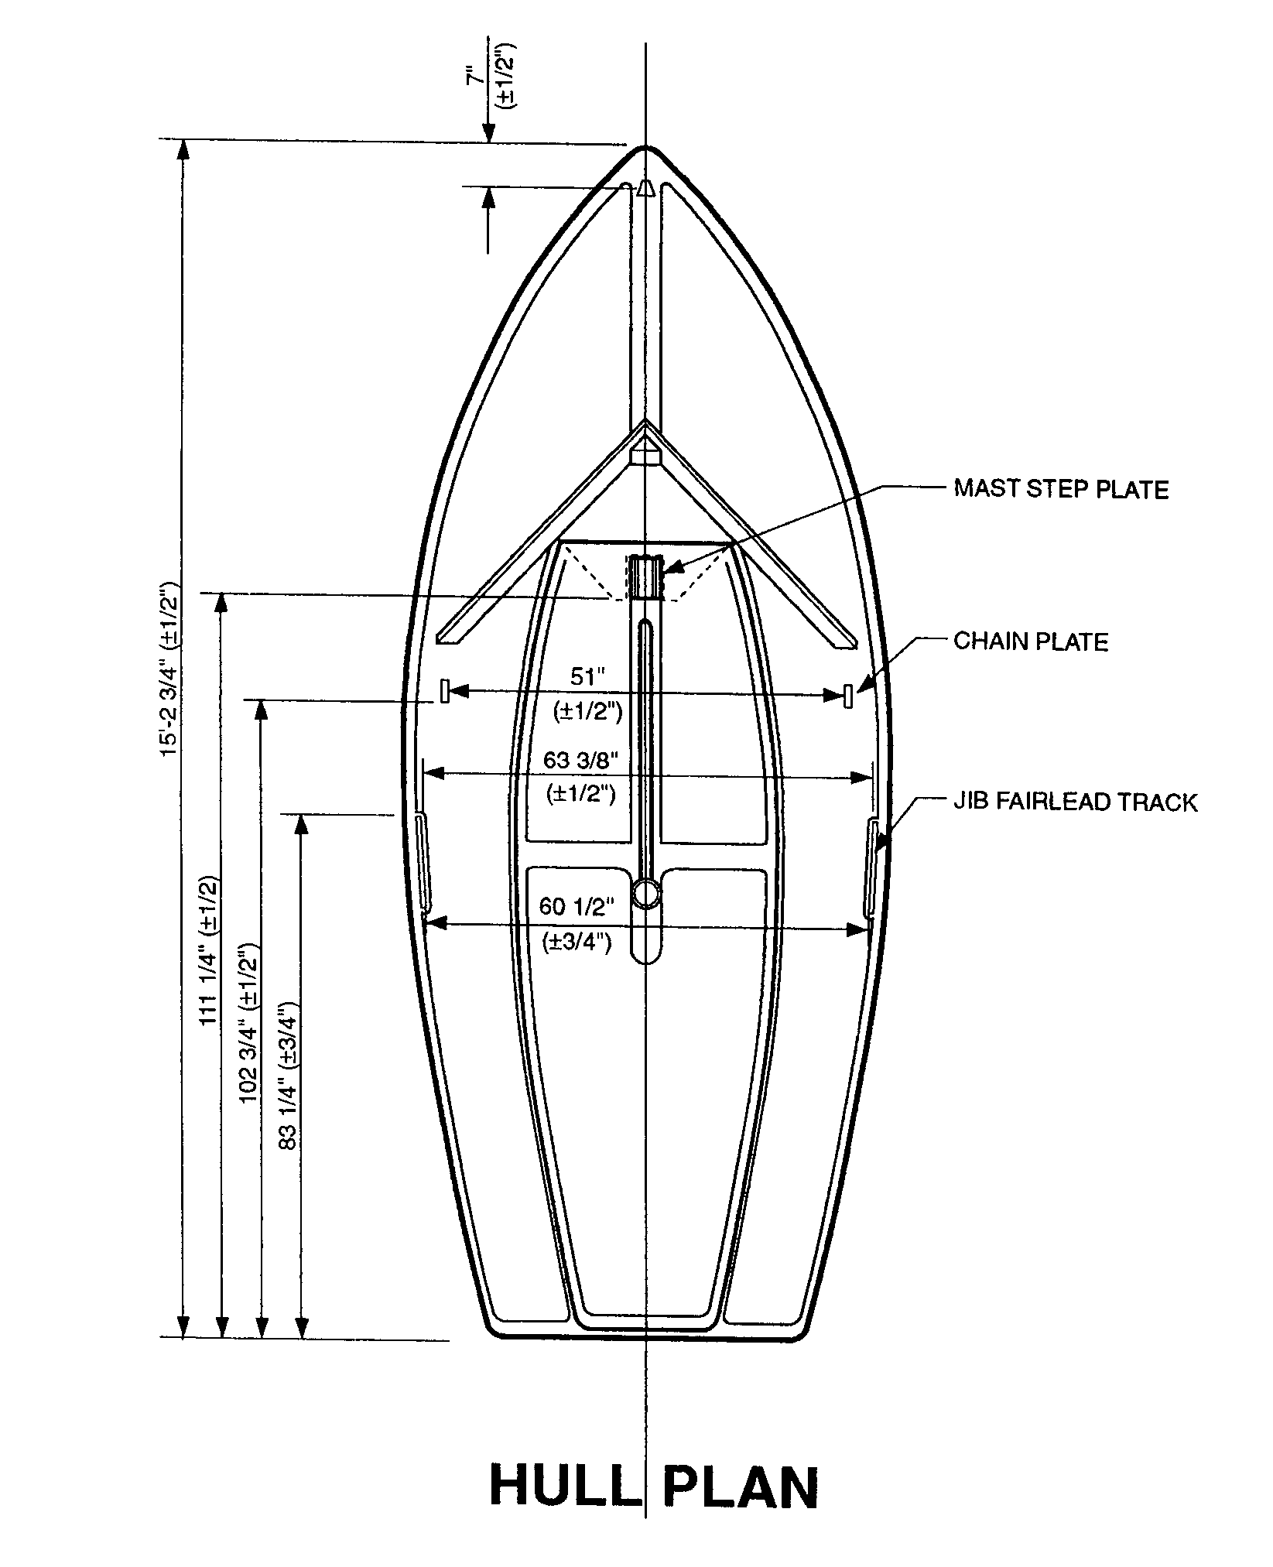

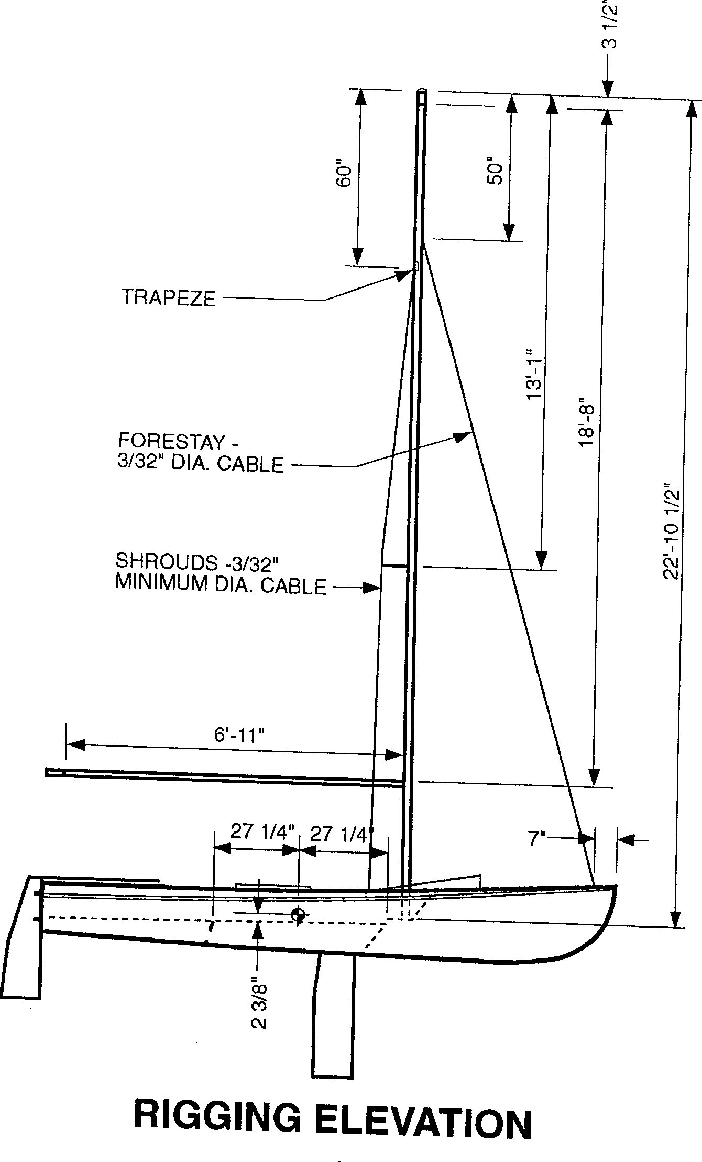

CENTERBOARD
(2) Width is measured at point of maximum width
(3) Width at bottom of board is measured between the extensions of the leading and trailing edge.
(8) Measure along the hull bottom, with board in full down position.
(9) The hull surface adjacent to the centerboard slot is used as the perpendicular reference.
(11) Measure jibe with board in full down position. Put pencil mark on leading edge. Place ruler against the hull directly in front of board and perpendicular to centerline of boat. Jibe the board manually by grasping the leading and trailing edges. Measure total movement of leading edge by using pencil mark as a reference. Measure movement of trailing edge using the same procedures. Subtract trailing edge movement from leading edge movement. This measurement must not exceed 1/4" (no tolerance).
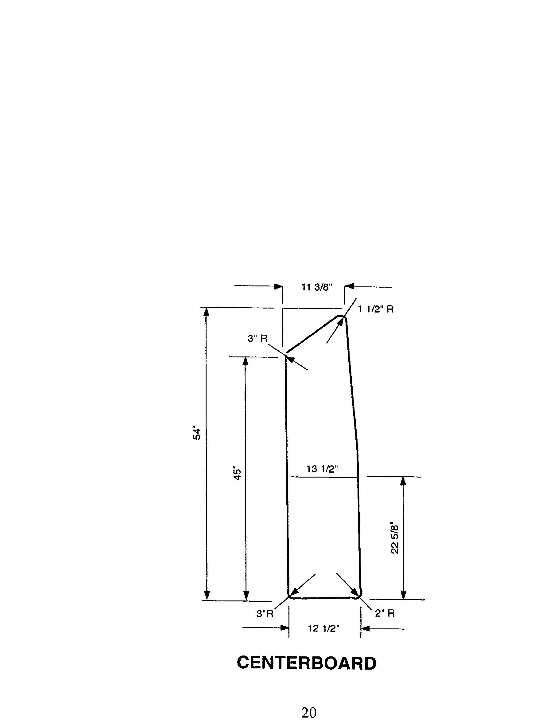

RUDDER
(1) Measured perpendicular to leading edge,
(2) Measured from bottom of boat, perpendicular to transom.
(3) The thickness measurement shall be taken at the thickest point.
(6) Place rudder on boat (in full down position). Place a straight edge (yardstick) along transom of boat. The leading edge of the rudder may not be further forward than parallel to the transom.
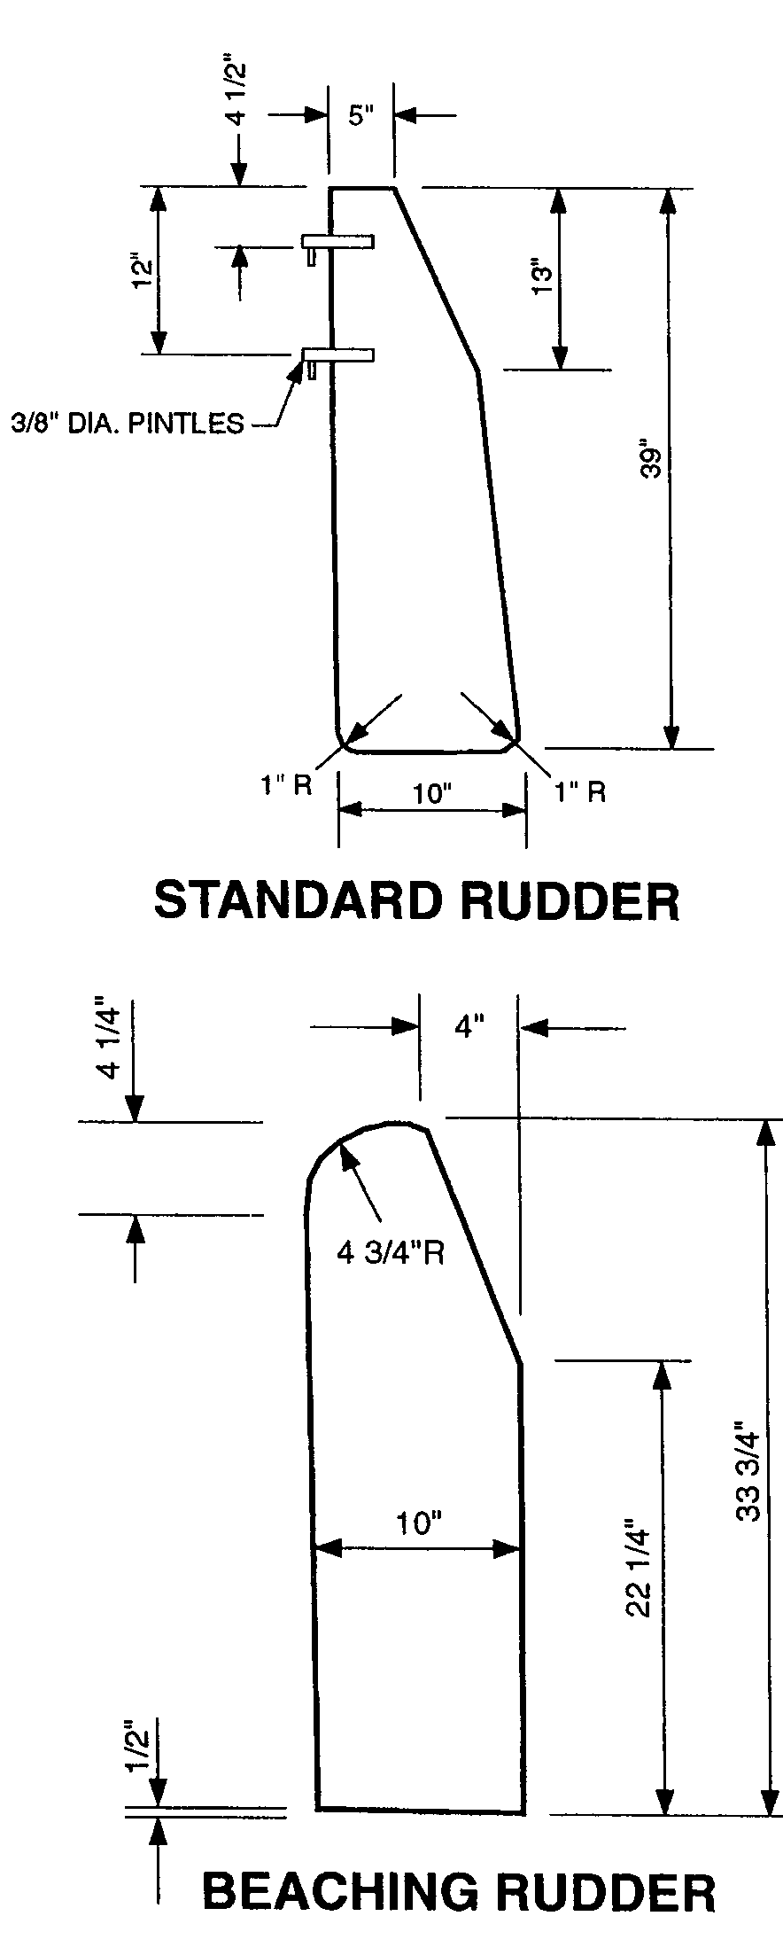

MEASURING RADIUS FOR RUDDER AND CENTERBOARD
(1) There are a number of radius requirements for the centerboard and the rudder. Below is an example of how to measure for a 2" radius. Follow the same procedure for other radius measurements. For the purpose of this example centerboards and rudders will be referred to by the generic term BLADES.
Using a ruler draw a box with each side having a length of 2". Using a compass draw three concentric 90 degree arcs on cardboard or Mylar, with the center of the am being the comer of the box. The center should have a radius of 2". The inside arc should have a radius of 1 ". The outside arc should have a radius of 2 1/4". The inside and outside arcs represent the 1/4" tolerance on radius measurements provided for in the Bylaws.
Lay the blade on the drawing so that the corner of the box (opposite the center < the arcs) would represent the comer of the blade (if the blade had a square comer).
The curved radius of the blade must fall BETWEEN the inner and outer arcs.

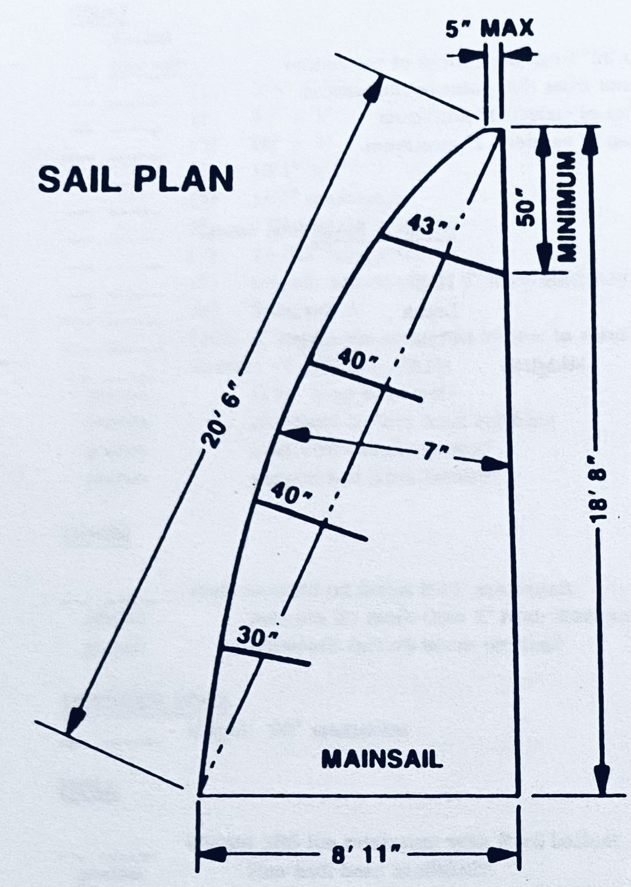
MAIN SAIL
(2) National designation letters and sail numbers shall be 10" high and shall be located below the insignia and above the bottom batten.
(7-9) Measure distance between centers of consecutive battens at the leech. The maximum difference between batten spacing may not exceed 6".
(13) The midgirth shall be subject to a direct line pull with only that tension applied to remove all wrinkles. The head measurement point is defined as the intersection of a line tangent to the inside edge of the boltrope and a line tangent to the top of the headboard. The tack measurement point is defined as the intersection of a line tangent to the inside edges of both boltropes. The clew measurement point is defined as the intersection of a line tangent to the inside edge of the boltrope and a line tangent to the extreme edge of the leech.
Procedure:
(1) Fold sail so that head and tack measuring points are together, mark mid-point on luff.
(2) Place head and clew measuring points together. Mark mid-point on leech.
(3) Measure girth between marks from extreme edge of leech to inside edge of boltrope.
(14) The leech shall be measured between the forward edge of the top of the headboard and the clew measurement point, the leech shall be subject to a direct line pull with only that tension applied to remove all wrinkles.
(15) Place a straight edge from centerpoint on trailing edge of batten pocket to same point on adjacent batten pocket. Distance from straight edge to any part of leech shall not exceed 1/2".

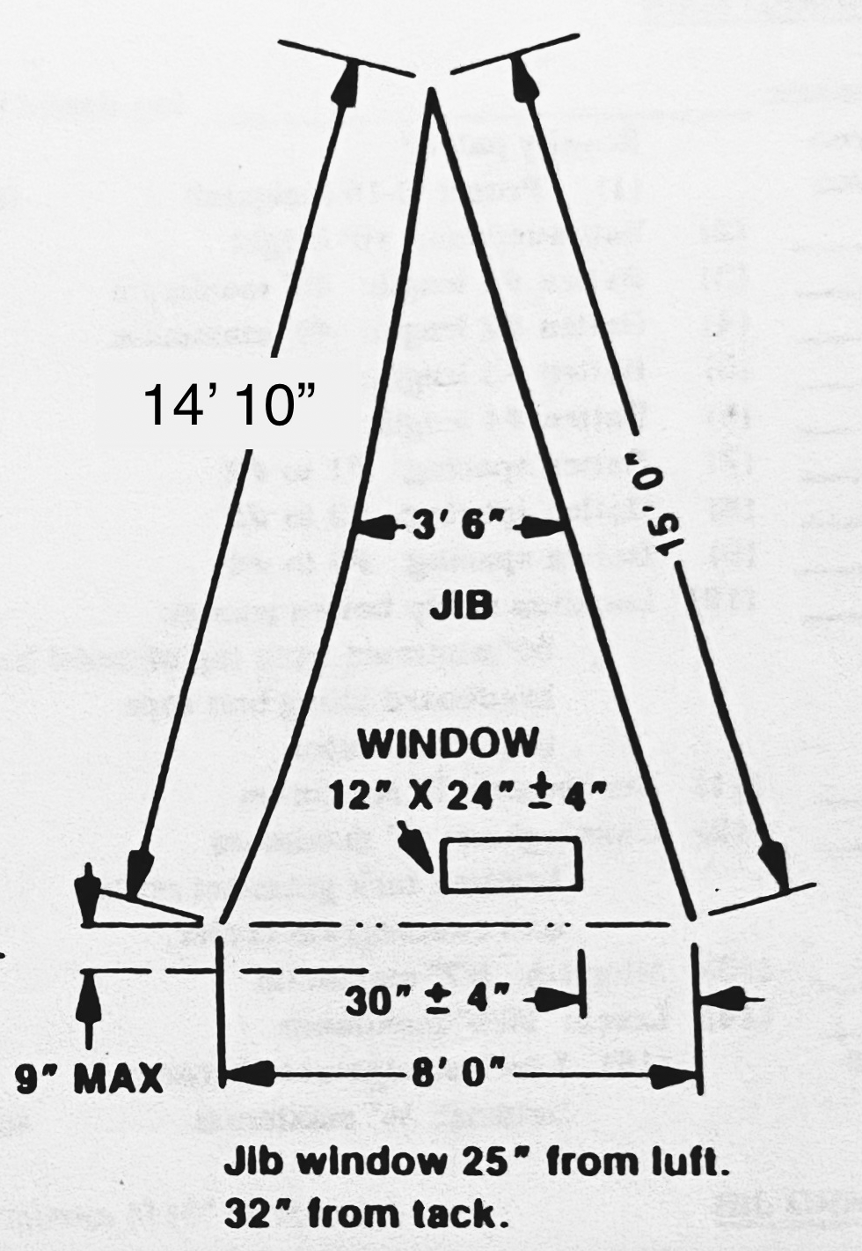
JIB
Note: The extreme edge of the tack, clew and head is defined as the actual intersection of cloth.
(2) Measure from forward lower comer of window to luff on a line perpendicular to luff.
(3) Measure from forward lower comer of window to extreme edge of the tack.
Note: The sail shall be subject to a direct pull sufficient to remove all wrinkles while it is being measured.
(5) The luff shall be measured from the extreme top of the sail to the extreme far edge of the tack, but excluding the thimbles.
(6) The foot shall be measured from the extreme far edge of the clew to the extreme far edge of the tack.
(7) The leech shall be measured from the extreme top of the sail to the extreme far edge of the clew.

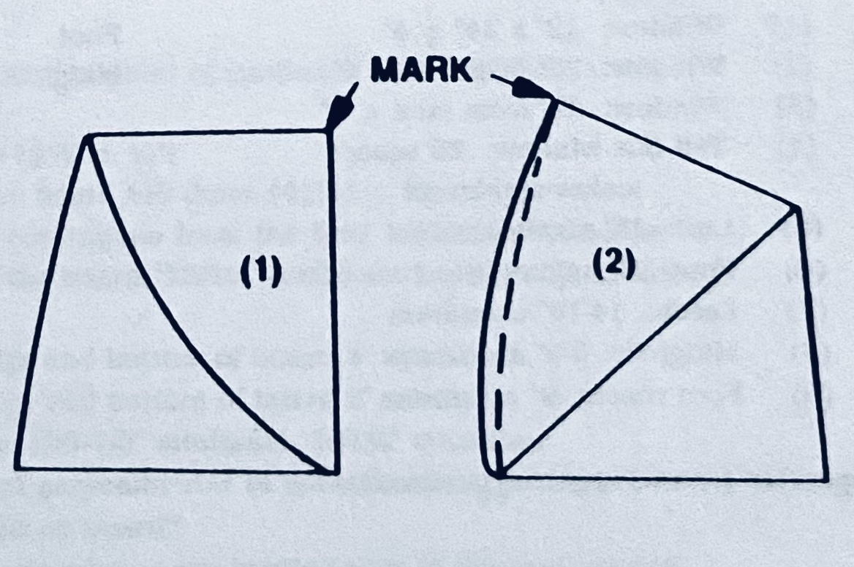
(8) Procedure:
(1) fold sail so that extreme top of sail and extreme edge of tack are together; mark mid-point on luff.
(2) Place extreme top of sail and extreme edge of clew together; mark midpoint on leech.
(3) Measure girth between marks from extreme edge of leech to extreme edge of lull.
(9) Place a straight line from the extreme edge of the clew. distance from the straight line to any point on bottom of sail shall not exceed 9".

Example of measurement sheet circa 1986:
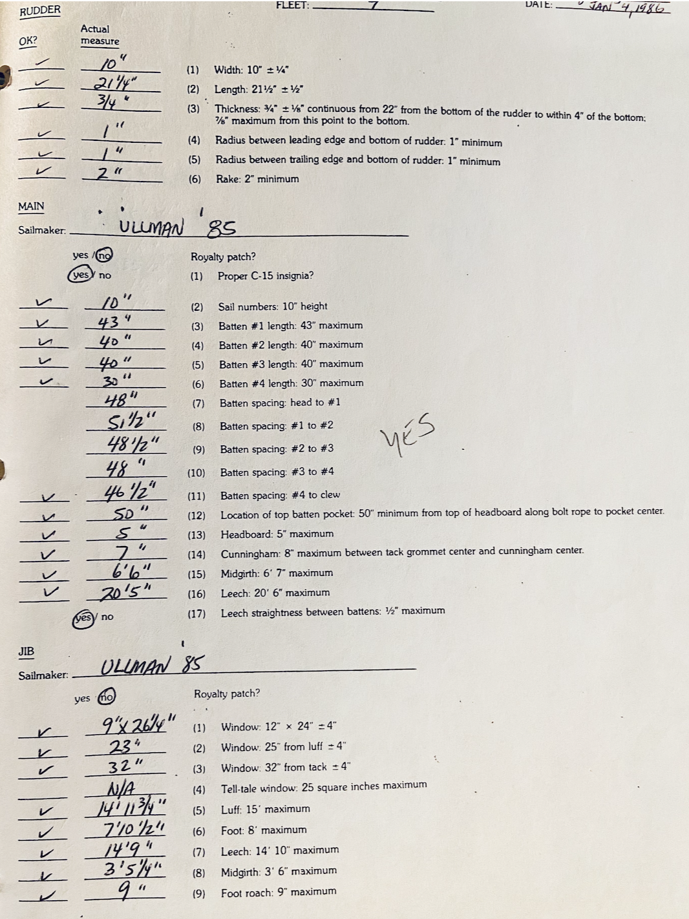

Revisions:
2010: Allow Hi-Tech lines for Halyards
2012: Two window jib option
2017: Allow Hi-Tech lines for standing rigging
2022: Remove forestay attachment specification.
Corrected errors in sail diagrams
Added example of old measurement sheet
2024: Removed requirement that boom be aluminum

